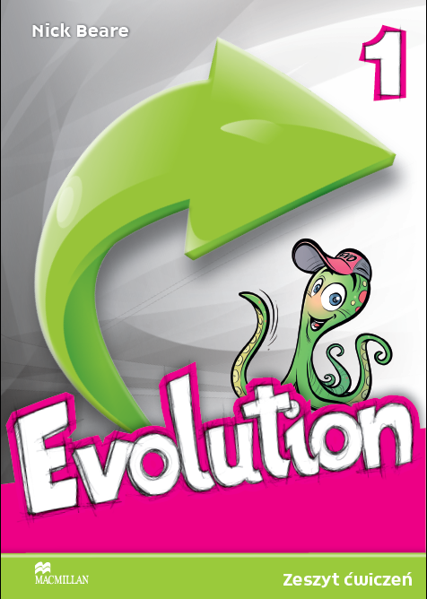

?
Revolution or
Organising learning for upper-primary students
Language instinct
a complex specialised skill develops in a child spontanously without conscious effort and awareness of its underlying logic as a result of experience processed with the repertoire of cognitive abilities available at a given moment. Steven Pinker (1995)
Knowledge
- use games, puzzles, visuals and secret codes
- use kinesthetic activities to teach grammar
Developing 5 content areas

Reception
- use challenging tasks, riddles, authentic materials
- use interesting content from all subject areas

Production
- give a model for guided but interesting writing tasks
- use projects combining language and other skills

Nowa Podstawa Programowa
Mediation
- runnig dictation (script below)
- twisted stories (script below)
Interaction
- use genuinely communicative tasks
- encourage students to correspond with an e-pal

Extralinguistic content
- evoke curiosity through games, riddles and interesting topics from all subject areas
- raise tolerance through presenting culture materials
- engage students in pair and group work activities
- develop responsibility not only for learning but also in a broader social dimension

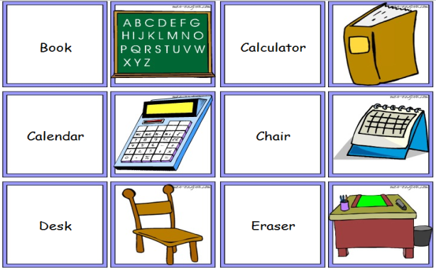
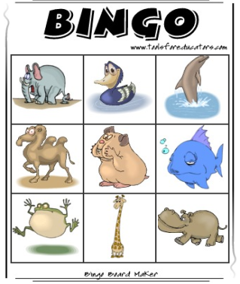
Games – make your own printable bingo cards and domino

http://www.toolsforeducators.com/
epals webpage – e-mail exchange for children at all ages
http://www.studentsoftheworld.info/menu_penpals.php



- the ability to transform a message from its written to spoken form and from spoken to written form.


Twisted stories
Goal: students will be able to retell a story they read and write a story they heard
Materials: photocopies of 2 simple but not too short texts (or regular coursebook reading texts) that are new for the students
Procedure:
- Divide the class into 2 teams. One team will be working with text 1 and the other with text 2
- Students work in pairs. Student A reads one text and tries to remember as much as possible. Student B prepares a piece of paper and a pen.
TEAM A TEAM B
Read text B
Read text A

- Student A puts the text away and retells the text to student B with as much detail as he can remember.
- Student B listens carefully but doesn’t make notes and doesn’t ask questions

speak
listen
listen
speak

- When student B has finished, student A writes the story down with as much detail as possible
write
write

read

- When they finish there is a Twist – they meet with a pair from the other team.
- Students exchange the texts they have written I such a way that the one who was writing will now be reading the text prepared by the other team

Exchange of texts
Read text A
Read text B
Text A
Text B

- Students repeat steps 2-5
- When they finish they compare the second version of their text with the original to find all differences.
- The team whose text is closest to the original are the winners!

R u n n i n g D i c t a t i o n
Goal: students will be able to retell a story they read and write a story they heard
Materials: 4-5 photocopies of 2 simple but not too short texts that are new for the students
Procedure:
- Stick the texts on one wall of the classroom
- Ask students to sit next to the opposite wall
- Put students in pairs. One is the Runner and the other is the Writer
- On your mark Runners run to one of the copies hanging on the wall
- They read one sentence and try to remember it as accurately as possible
- Runners come back to their writers and dictate the line
- Writers listen carefully and write the sentence down
- Runners go back to their text and so on until they dictate the whole text
- Runner and Writer read the text and make necessary changes
- Teacher reads the texts and students compare it with their texts
- The pair that is closest to the original wins

- Use two different texts to make sure that the writers listen to their own Runners and are not disturbed by other Runners dictating the same texts so the seating should be organized in a way that two groups sitting next to each other work on different texts.
runner
writer
runner
writer
text 2 text 1 text 2 text 1

text 2 text 1 text 2 text 1

runner
writer

runner
runner
runner
writer

writer

writer

runner
writer
runner
writer

enjoy!

